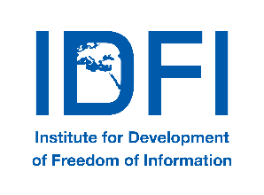
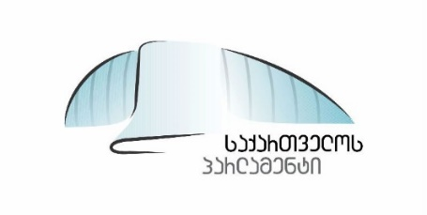
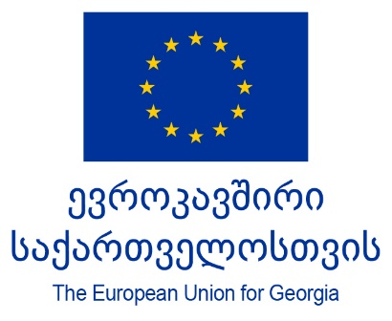

Meeting of the Permanent Parliamentary Council on
Open Governance & its Consultative Group

Venue: Holiday Inn Hotel, Tbilisi
11 December 2018
Agenda
11:30 – 12:00 - Registration – Coffee / Tea

12:00 – 12:15
Opening Remarks
- Irina Pruidze, Chairperson of the Permanent Parliamentary Council on Open Governance
- Tamar CHUGOSHVILI, First Deputy Chairperson of the Parliament of Georgia
- Sophie Huet Guerriche, Governance Sector coordinator, EU Delegation to Georgia (TBC)
- Gigi Bregadze, UNDP Democratic Governance Team Leader
- Giorgi KLDIASHVILI, Executive Director, Institute for Development of Freedom of Information (IDFI)

12:15 – 12:40
Update Report on Implementation of Commitments under 2018-2019 Open Parliament Georgia Action Plan
- Irina Pruidze, Chairperson of the Permanent Parliamentary Council on Open Governance
- Eka BESELIA, Chairperson of the Legal Issues Committee, Chairperson of the working group “Creation of a Citizen Engagement Center in the Parliament of Georgia”

12:40 - 13:10
Review of New Applications for the Consultative Group Membership

13:10 – 14:10
Commitment 5.1. Presentation/Discussion of the Draft Communication Strategy & Action Plan of the Permanent Parliamentary Council on Open Governance
- Meri MAKHARASHVILI, Communications Manager, IDFI
- Discussion

14:10 - 15:10 - Lunch

15:10 – 16:10
Commitment 5.4. Presentation/Discussion of the Draft Social Media Communication Concept of the Parliament of Georgia
- Meri MAKHARASHVILI, IDFI
- Discussion

16:10- 16:20 – Wrap Up & Closing Remarks

