Short Bios of Experts

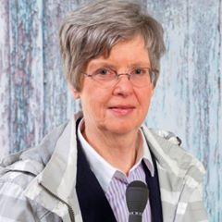
Melanie Sully is Director of the Go-Governance Institute in Vienna
(www.go-governance.com). Previously, Dr. Sully was a professor of political science at the Diplomatic Academy, Vienna, and worked as a correspondent for Voice of America. She has worked as a consultant on good governance, parliamentary standards, women’s political participation, legislative standards and other projects for the Federal Ministry for European and International Affairs of Austria, the Council of Europe and the OSCE. Dr. Sully is a guest professor at the University of London and a member of the Royal Institute of International Affairs in London.

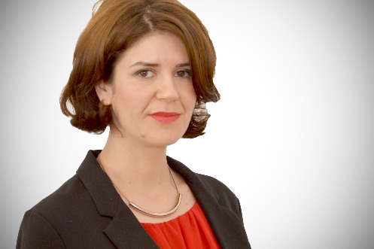
Sandra Pernar is Senior Advisor at the Croatian Government Office for Cooperation with NGOs. Her responsibilities include developing and implementing strategic documents falling within the Office’s remit, such as the Action Plan for the Implementation of Open Government Partnership Initiative in the Republic of Croatia and the National Strategy for Creating and Enabling Environment for Civil Society Development. On the international level, she is a member of the Board of Directors of the Open Government Partnership Secretariat and OGP Point of Contact for Croatia. Previously, Ms Pernar worked on good governance and civic participation issues at the civil society organization GONG, including serving as its Executive Director for two years. She graduated from the Faculty of Political Science of the University of Zagreb.

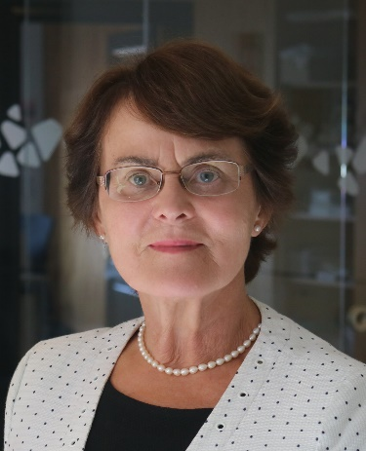
Liia Hänni is a Senior Expert on e-Democracy at the e-Governance Academy (eGA) in Tallinn. Since 2005, she has been managing the eGA e-democracy domain, which aims to improve the functional mechanisms of democracy with the help of ICT. Dr. Hänni graduated from the University of Tartu in Physics. She made a transition to politics in 1990 when she was elected to both the Supreme Council and Congress of Estonia. She worked closely on issues related to the restoration of Estonian statehood as a member of working groups and was the chair of the editing committee of the Constitutional Assembly. Dr. Hänni was elected to the 7th, 8th and 9th parliaments of Estonia. From 1992 to 1995, she was a minister responsible for the implementation of ownership reforms.

